**Sales and Specification Analysis of Mobile Devices**

Final Project Report – Module 7

**Data Visualization (Course Code: 80SU25)**

Northwest Missouri State University

**Submitted by:** Tesfamariam Ghezehey

**Date:** June 2025

The submission includes:

📄 Final Project Report (.docx)

📊 Tableau Workbook (.twbx)

📈 Excel data files used for analysis

🔗 GitHub Repository: <https://github.com/Tesfamariam100/Data-Visualization-Final-projects>

8. A. **Introduction:**

This project explores mobile sales data to uncover patterns in consumer preferences, product performance, and regional trends. Using Tableau and Excel, we analyzed key factors such as total revenue, quantity sold, processor specifications, RAM, ROM, and SSD configurations. The project also includes a donut chart to visualize the market share distribution among major mobile brands. By combining geospatial and categorical insights, this analysis supports strategic decision-making for inventory planning, product development, and regional marketing efforts

**8. B.** Domain of the Dataset

This dataset falls under the consumer electronics and retail analytics domain. It includes 50,000 sales transactions for mobile phones and laptops, covering product specs, pricing, customer details, and regions. The data supports use cases in sales analysis, customer behavior, inventory tracking, and business intelligence.

8. C. Cleaned dataset file:[**cleaned_mobile_sales_data**](https://docs.google.com/spreadsheets/u/0/d/1bx-3lgi_imXPJof1YCG3eE5sBXQomyH09AOPXeYZfxM/edit)

8. D. Data Source: <https://www.kaggle.com/datasets/vinothkannaece/mobiles-and-laptop-sales-data>

8.E Number of Records: 50,000, Number of Columns: 18

8.F. Tools Used: Excel, Tableau, MS Word

8. g. Data Cleaning Strategies:Converted Inward Date, and Dispatch Date to datetime

Removed Core Specification, and Fill missing SSD values with N/A

Standardized RAM/ROM units

Saved as cleaned_mobile_sales_data.xlsx

8. h. Cleaned dataset: attached [**cleaned_mobile_sales_data**](https://docs.google.com/spreadsheets/u/0/d/1bx-3lgi_imXPJof1YCG3eE5sBXQomyH09AOPXeYZfxM/edit)

**Project Goals**

**8. i-1. Goal**: Identify the top-performing brands based on total revenue using a bar chart.

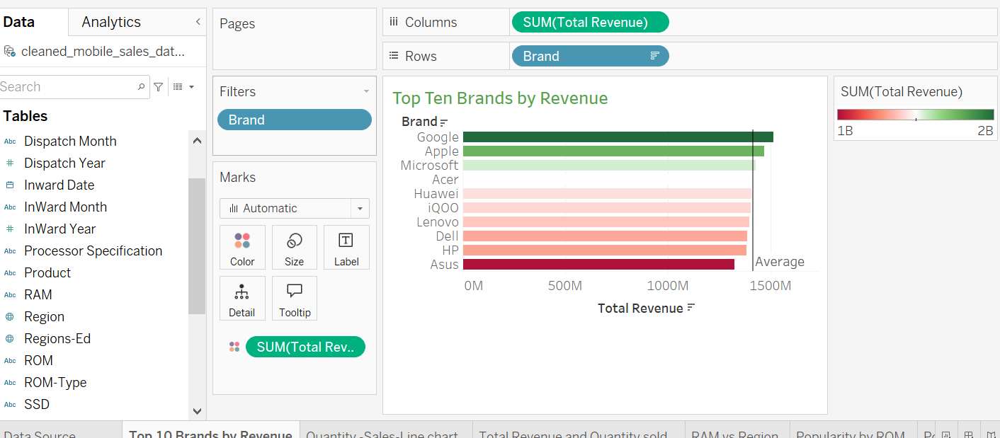

**J. Story**: This chart highlights the top 10 brands by total revenue, with Google, Apple, and Microsoft leading the market. A color gradient from green to red shows revenue performance, making it easy to compare brand success immediately.

8. i-2. **Goal**: Track monthly sales trends over time. Visualize how total revenue or quantity sold changes across months and years to identify seasonality, sales spikes, or performance dips.

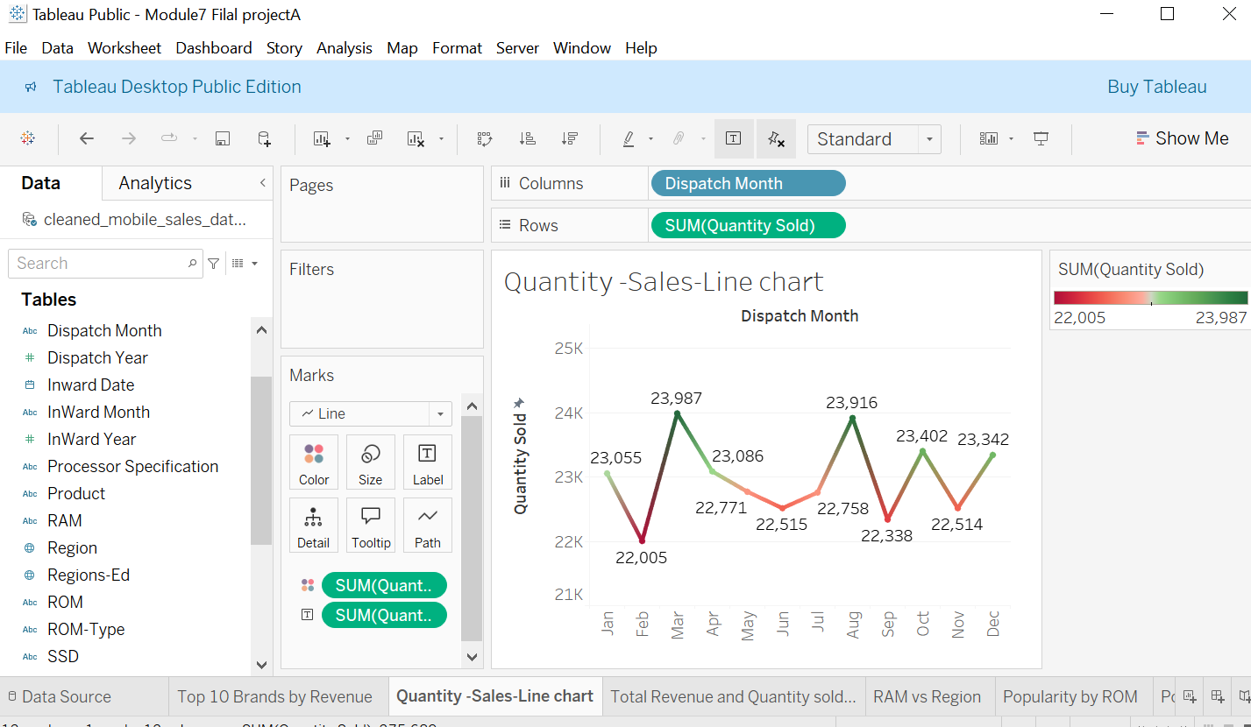

**J. Story**: This line chart shows the monthly trends in total revenue and quantity sold, based on the dispatch date. It shows cintineous fluctuations throughout the year, with notable sales peaks in **March**, **August**, and **October**. These trends help identify high-performing months and potential seasonal buying patterns, supporting future forecasting and inventory planning.

8. i-3 Visualize total sales by **region** using filled maps and cicle charts to identify geographic demand differences.

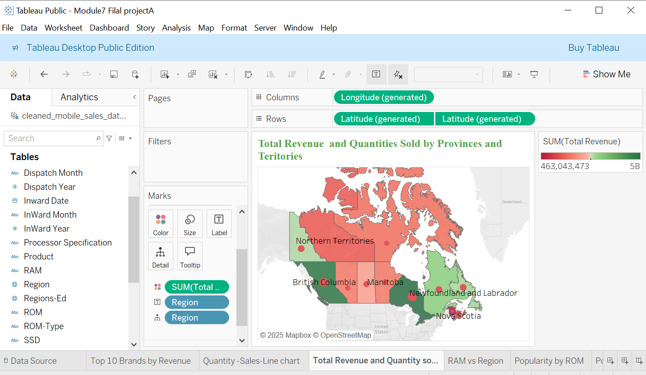  
**J. Story:**  
 This dual-layer map provides a clear geographic breakdown of mobile device sales across Canada, highlighting both **total revenue** (via color intensity) and **quantity sold** (via circle size). Provinces such as **Alberta** and **British Columbia** stand out prominently. Alberta, for instance, not only generated the **highest revenue** at over **$1.7 billion**, but also achieved **strong unit sales** (16,488), represented by a large red circle. In contrast, territories like **Nunavut** and **Northern Territories** show **smaller circles and lighter shades**, indicating lower market penetration and sales. By combining revenue and quantity in a single view, this map effectively captures both **profitability and sales volume**, offering valuable insight into regional market performance and customer demand patterns.

**8. i.4 Goal:**   
 Analyze the distribution of RAM sizes sold across Canadian regions to identify which memory capacities are most popular in different markets.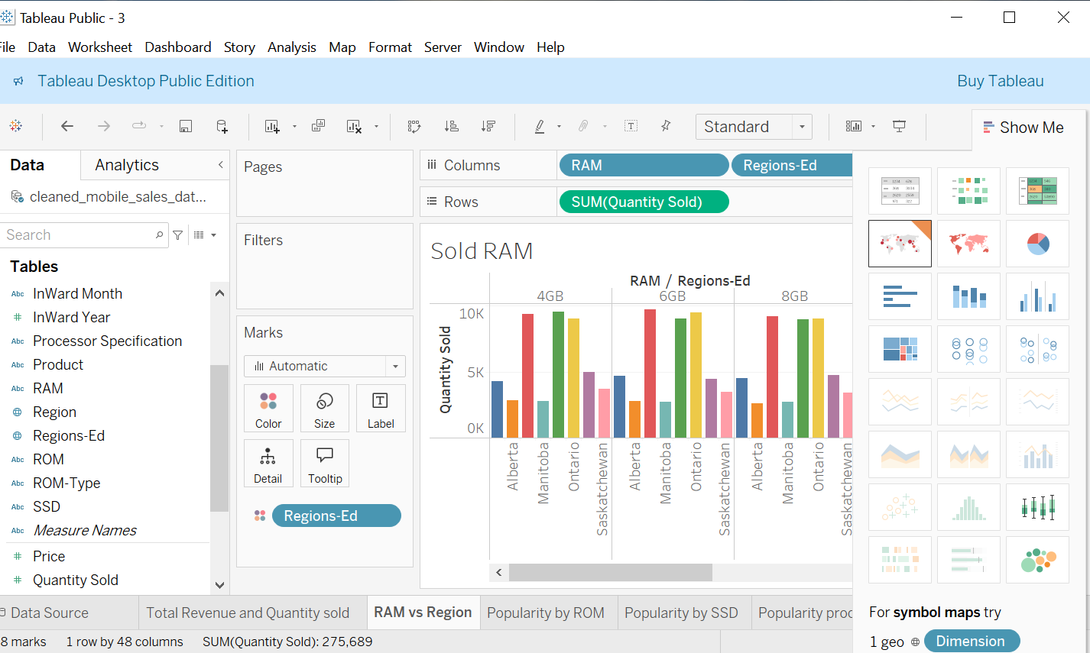

**J. Story:** This chart reveals regional preferences for different RAM capacities across Canada. Ontario and Manitoba consistently show the highest sales volumes for all RAM sizes, indicating strong market demand. Among RAM options, 6GB and 4GB are the most popular across regions, with 8GB slightly trailing. Saskatchewan shows moderate sales, while Alberta lags slightly behind. These insights suggest that mid-range RAM configurations dominate the market, with Ontario consumer demand.

**8 i. 5. Goal:** Determine which ROM capacities are most popular by analyzing total quantity sold, helping to identify customer preferences for storage options.

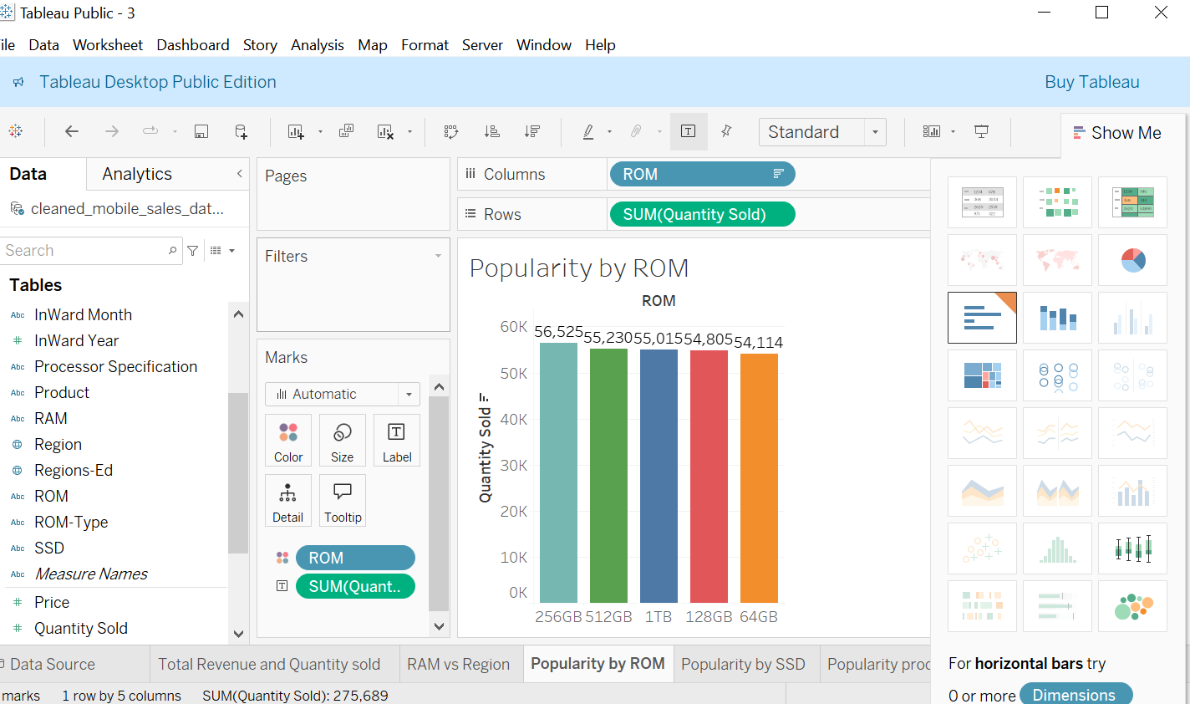

**J. Story**:  
 The chart shows that 256GB and 512GB ROM options are the most popular among customers, each selling over 55,000 units. This indicates a strong demand for mid-to-high storage capacity devices, while lower (64GB) and higher (1TB) capacities see relatively lower sales, suggesting customers prefer balanced storage solutions.

**8.i.6 Goal:**  
 Identify which processor specifications drive the highest product sales.

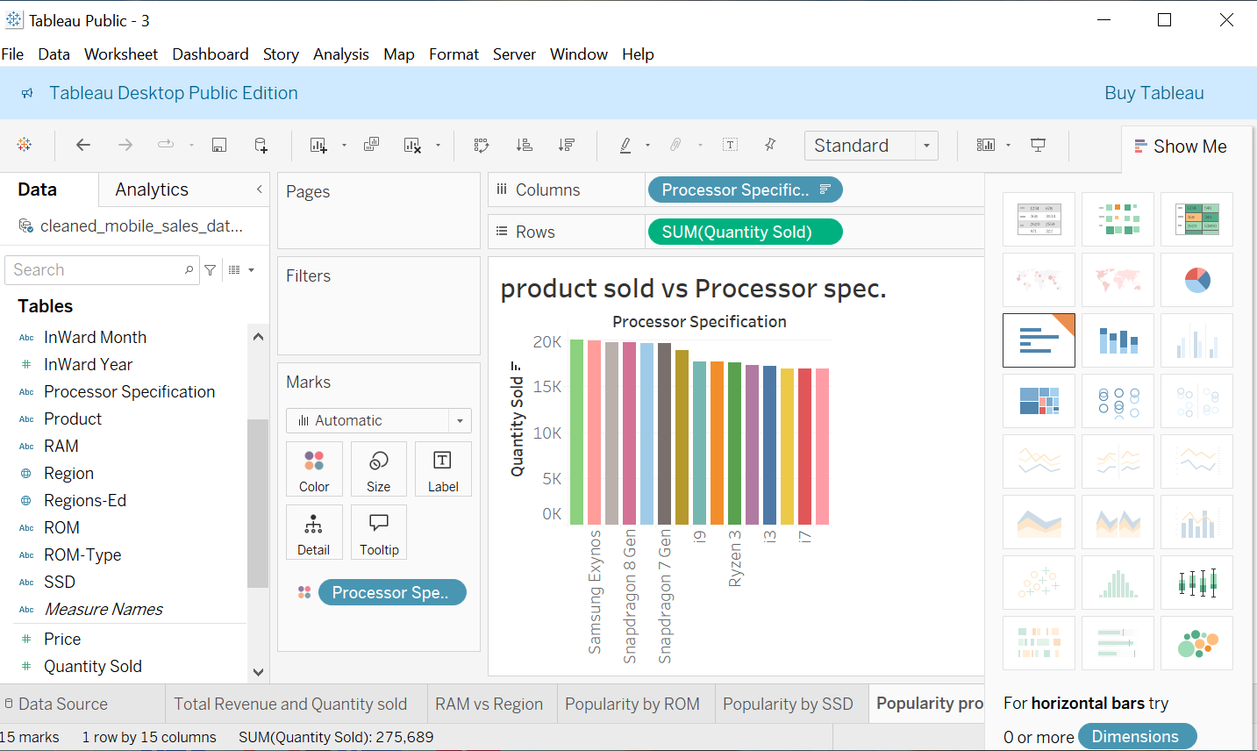

**j. Story:**  
 The chart reveals that devices with Samsung Exynos and Snapdragon 8 Gen processors lead in sales, surpassing 19,000 units sold. These are followed closely by Snapdragon 7 Gen and Intel i9 models. The data suggests a strong customer preference for higher-performance processors, with lower-tier options like i3 and i7 showing relatively lower sales volumes.

**8. i.7. Goal:** To visualize and compare the market share percentages of different mobile brands in a clear and engaging format. 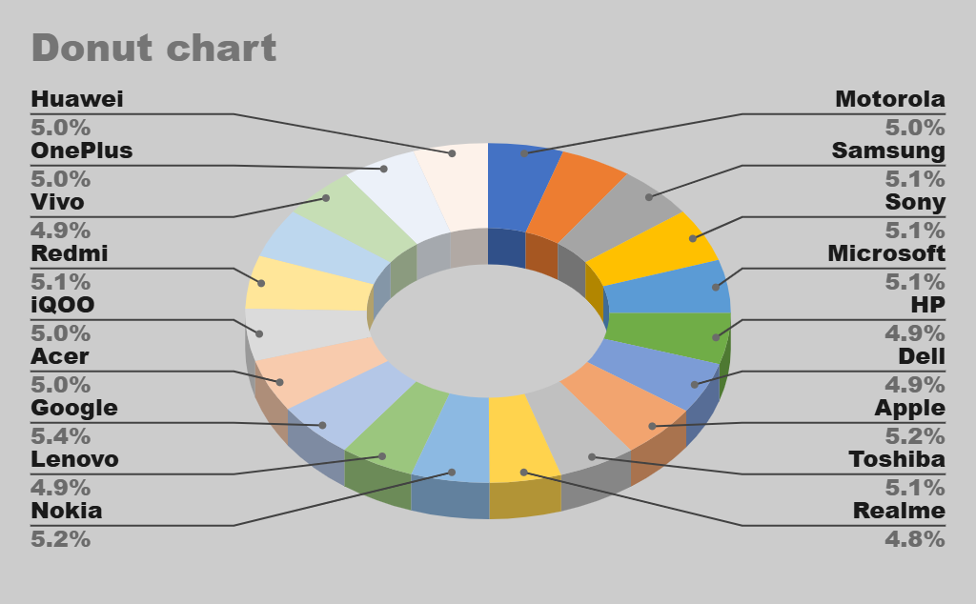Story: The donut chart illustrates the market share distribution across various mobile brands. Google leads with the highest share at 5.4%, followed closely by Nokia (5.2%) and Apple (5.2%). Most brands maintain a competitive margin around 5%, highlighting a relatively balanced market. This visualization helps identify top-performing brands and their proximity in sales, offering insights into brand competitiveness.

**Overall Conclusion:**

Our analysis provides a comprehensive view of mobile sales trends across Canada. The top 10 brands by revenue highlight Google and Apple as market leaders, while the sales line chart shows consistent monthly demand with noticeable peaks in March and August. Regional analysis via the map and bar charts reveals that provinces like British Columbia and Nova Scotia lead in both revenue and quantity sold. RAM and ROM preferences show strong customer interest in 4GB–6GB RAM and 1TB–512GB ROM options. Processor-wise, Snapdragon and Samsung Exynos dominate in volume.

Finally, the donut chart gives a balanced visual of brand market shares, showing that most brands hold similar percentages around 5%, with Google slightly leading at 5.4%. This indicates a competitive market landscape where no single brand has overwhelming dominance. Together, these insights help in understanding consumer preferences and regional sales dynamics for strategic decision-making.